|  |
| --- |
| **Introductory Session on**  **Exploring Java Using NetBeans** **LAB # 01**    **Name # Noman Amjad**  **Reg No # 21-arid-654**  **Section # BSCS 6C EVE** |

**Activity-1:**

A shop will give discount of 10% if the cost of purchased quantity is more than 1000.

Ask user for quantity. Suppose, one unit will cost 100. Judge and print total cost for user.

**Solution: /\***

**\* Click nbfs://nbhost/SystemFileSystem/Templates/Licenses/license-default.txt to change this license**

**\* Click nbfs://nbhost/SystemFileSystem/Templates/Classes/Main.java to edit this template**

**\*/**

**package activityy1;**

**/\*\***

**\***

**\* @author noman**

**\*/**

**import java.util.Scanner;**

**public class Activityy1 {**

**/\*\***

**\* @param args the command line arguments**

**\*/**

**public static void main(String[] args) {**

**// TODO code application logic here**

**final int UNIT_COST = 100;**

**// Create a Scanner object to read input from the user**

**Scanner SCANNER = new Scanner(System.in);**

**// Ask the user for the quantity**

**System.out.print("Enter the quantity of items you want to purchase: ");**

**int QUANTITY = SCANNER.nextInt();**

**// Calculate the total cost without discount**

**int TOTAL_COST = QUANTITY * UNIT_COST;**

**// Check if the total cost is more than 1000 to apply discount**

**if (TOTAL_COST > 1000) {**

**// Apply 10% discount**

**TOTAL_COST -= TOTAL_COST * 0.10;**

**}**

**// Print the total cost for the user**

**System.out.println("The total cost after discount (if applicable) is: " + TOTAL_COST);**

**}**

**}**

**Output Screenshot:** 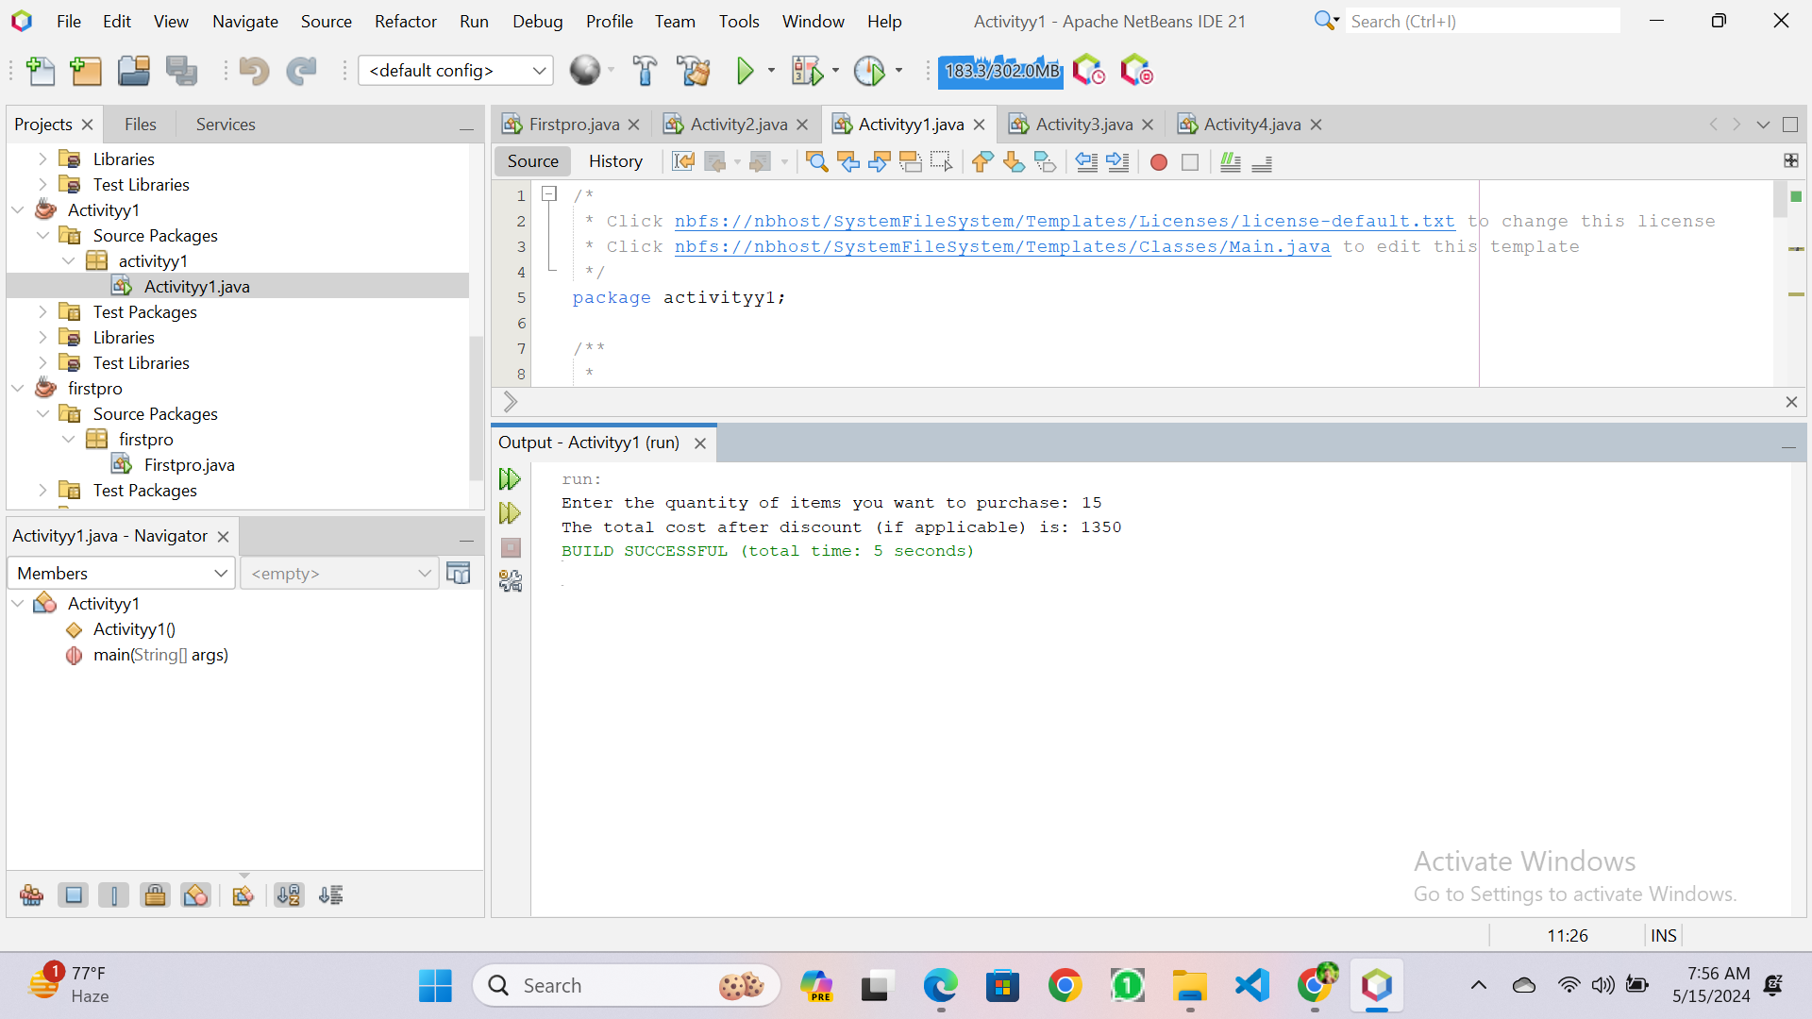

**Activity-2:**

Write a program to print absolute value of a number entered by user. E.g.- INPUT: 1 OUTPUT: 1

INPUT: -1 OUTPUT: 1

**Solution:**

**/\***

**\* Click nbfs://nbhost/SystemFileSystem/Templates/Licenses/license-default.txt to change this license**

**\* Click nbfs://nbhost/SystemFileSystem/Templates/Classes/Main.java to edit this template**

**\*/**

**package activity2;**

**/\*\***

**\***

**\* @author noman**

**\*/**

**import java.util.Scanner;**

**public class Activity2 {**

**/\*\***

**\* @param args the command line arguments**

**\*/**

**public static void main(String[] args) {**

**// TODO code application logic here**

**// Create a Scanner object to read input from the user**

**Scanner SCANNER = new Scanner(System.in);**

**// Ask the user to enter a number**

**System.out.print("Enter a number: ");**

**int NUMBER = SCANNER.nextInt();**

**// Calculate the absolute value**

**int ABSOLUTE_VALUE = Math.abs(NUMBER);**

**// Print the absolute value**

**System.out.println("The absolute value is: " + ABSOLUTE_VALUE);**

**}**

**}**

**Output Screenshot:** 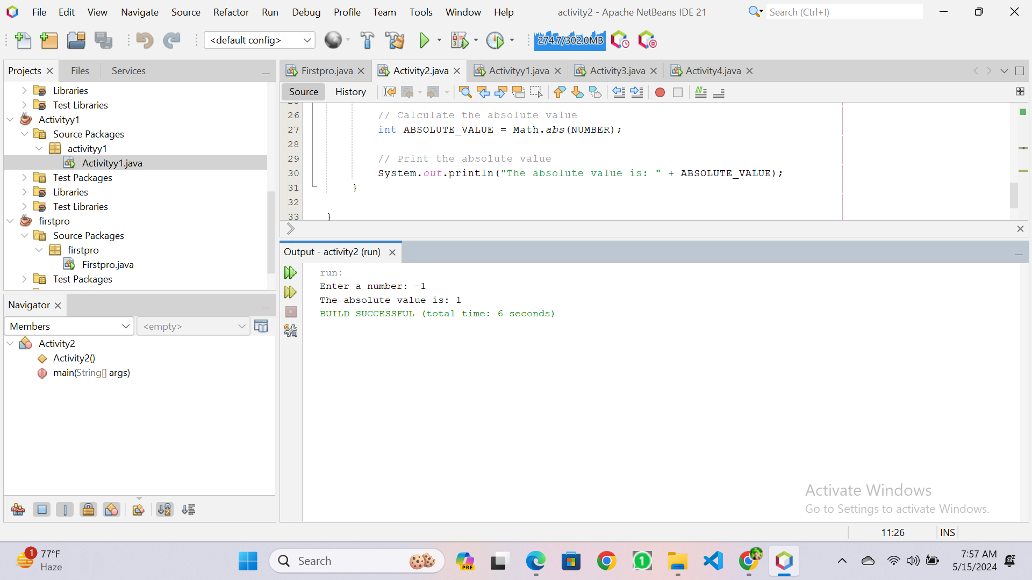

**Activity-3:**

A school has following rules for grading system:

1. Below 25 - F
2. 25 to 45 - E
3. 45 to 50 - D
4. 50 to 60 - C
5. 60 to 80 - B
6. Above 80 - A

Ask user to enter marks and print the corresponding grade.

**Solution: /\***

**\* Click nbfs://nbhost/SystemFileSystem/Templates/Licenses/license-default.txt to change this license**

**\* Click nbfs://nbhost/SystemFileSystem/Templates/Classes/Main.java to edit this template**

**\*/**

**package activity3;**

**/\*\***

**\***

**\* @author noman**

**\*/**

**import java.util.Scanner;**

**public class Activity3 {**

**/\*\***

**\* @param args the command line arguments**

**\*/**

**public static void main(String[] args) {**

**// TODO code application logic here**

**// Create a Scanner object to read input from the user**

**Scanner SCANNER = new Scanner(System.in);**

**// Ask the user to enter their marks**

**System.out.print("Enter your marks: ");**

**int MARKS = SCANNER.nextInt();**

**// Determine the grade based on the marks**

**char GRADE;**

**if (MARKS < 25) {**

**GRADE = 'F';**

**} else if (MARKS >= 25 && MARKS < 45) {**

**GRADE = 'E';**

**} else if (MARKS >= 45 && MARKS < 50) {**

**GRADE = 'D';**

**} else if (MARKS >= 50 && MARKS < 60) {**

**GRADE = 'C';**

**} else if (MARKS >= 60 && MARKS < 80) {**

**GRADE = 'B';**

**} else {**

**GRADE = 'A';**

**}**

**// Print the grade**

**System.out.println("Your grade is: " + GRADE);**

**}**

**}**

**Output Screenshot:** 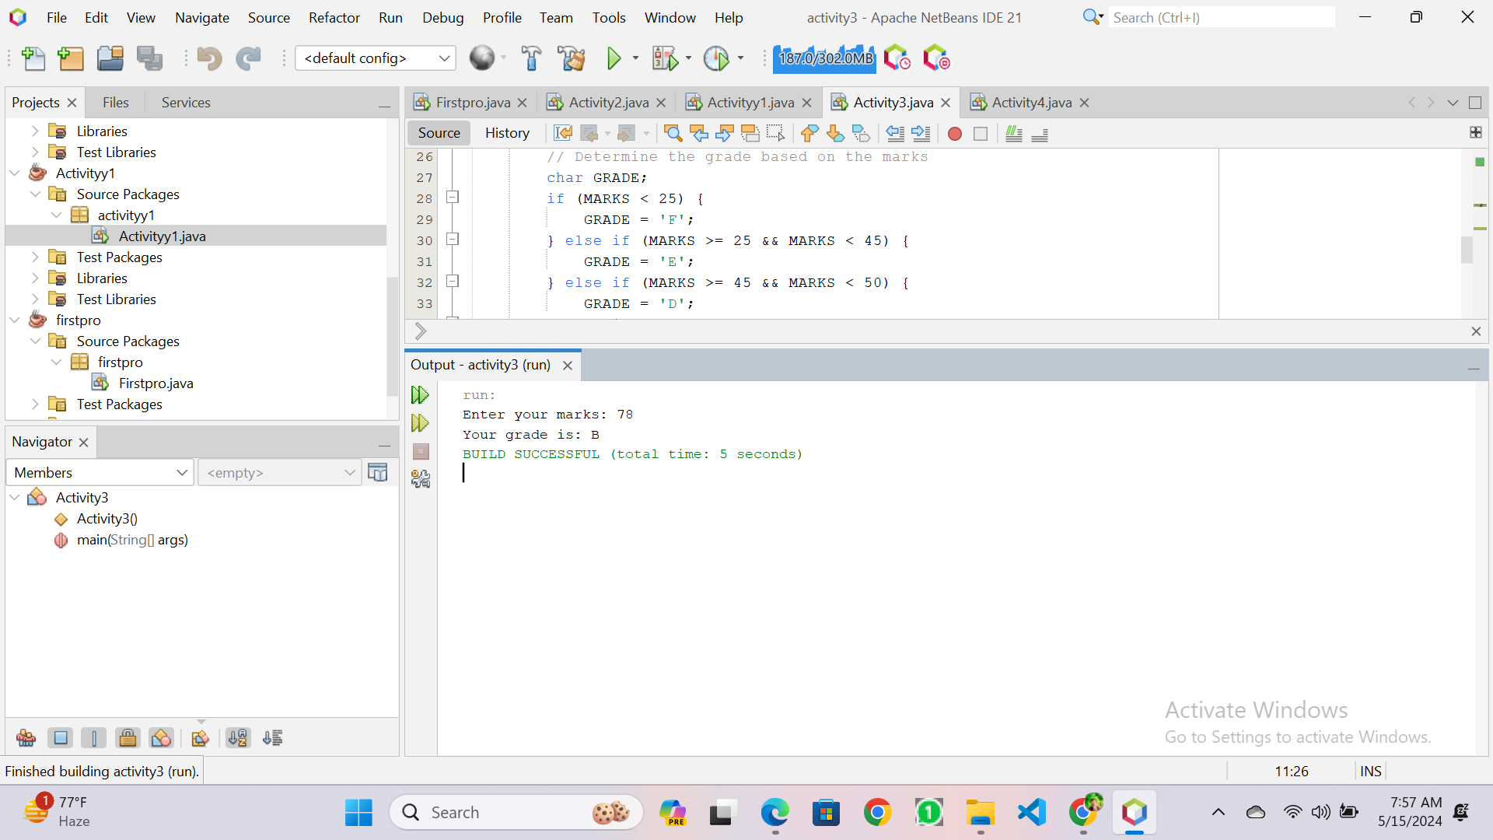

**Activity-4:**

Take values of length and breadth of a rectangle from user and check if it is square or not.

**Solution: /\***

**\* Click nbfs://nbhost/SystemFileSystem/Templates/Licenses/license-default.txt to change this license**

**\* Click nbfs://nbhost/SystemFileSystem/Templates/Classes/Main.java to edit this template**

**\*/**

**package activity4;**

**/\*\***

**\***

**\* @author noman**

**\*/**

**import java.util.Scanner;**

**public class Activity4 {**

**/\*\***

**\* @param args the command line arguments**

**\*/**

**public static void main(String[] args) {**

**// TODO code application logic here**

**Scanner SCANNER = new Scanner(System.in);**

**// Ask the user to enter the length of the rectangle**

**System.out.print("Enter the length of the rectangle: ");**

**int LENGTH = SCANNER.nextInt();**

**// Ask the user to enter the breadth of the rectangle**

**System.out.print("Enter the breadth of the rectangle: ");**

**int BREADTH = SCANNER.nextInt();**

**// Check if the rectangle is a square**

**if (LENGTH == BREADTH) {**

**System.out.println("It is a square.");**

**} else {**

**System.out.println("It is not a square.");**

**}**

**}**

**}**

**Output Screenshot:** 